Team 9, Paper Design

**Hearing colours in space**

Harpo 't Hart & Philipe Louchtch

October 25, 2012

Concept Interface Design

As discussed earlier in the Project Plan, we will provide whole range of different interfaces. These are the voice commands, the GUI configuration window and the world itself.

The World

The world around the user or to be more precise, the field of vision of the Kinect-sensor that is mounted on the head of the user is the interface for sound manipulation. The colours seen by the sensor are translated into sounds. The user has control over the sound produced by ‘looking’ at or walking towards colourful planes. The user has control over how many parts of the image are generating colours, in the range between 3 and 7 in steps of two. Thus 3, 5 and 7 are available choices.

Furthermore, the user is able to decrease the size of such a part from which colour information is generated by using the “zoom” parameter.

A few simple pictures illustrating how the sensor will see the world are presented later on in this document.

Voice commands

Once the user has started using the device it is important not to break the flow of the interaction by requiring any change to be made on the computer with a mouse and keyboard. Which would require the user either to walk to the computer or to take the laptop out of the backpack that is connected to the device, this seems counterproductive and thus voice commands should be made available to the user.

The commands should be short, logical and be prefixed with a special keyword. The rationale for this is simple, short commands are easier to detect, remember and pronounce. If the commands make sense, are logical or otherwise natural, the learning curve is decreased dramatically since the user is able to make well educated guesses into which words are available to him or her. The prefixed keyword is also important in order to prevent issuing unintended commands.

The possible commands are outlined at the end of this document.

The Graphic User Interface configuration window

Whilst the voice commands should provide a nice way of changing the runtime parameters of the device without physical interaction of the user with a machine, we recognize that this is not always ideal. Especially when a user wants to quickly tweak the default parameters before putting on the device or even to experiment with the parameters, fast.

Therefore, the configuration window should not be limited to being a quick configuration option before turning on the device, but should remain functional even during the use of the device. This isn’t hard to implement.

A screenshot of a partially implemented configuration window is included at the end of this document.

**User analysis**

Our users are creative people who are most likely not very technical but are able to navigate modern day technology such as modern operating systems running on computers and smartphones with relative ease. The voice and GUI interfaces should adhere to the usability expectations and mental model of such users and thus must provide easily understandable parameters and controls.

Because our user group is creative people, mainly those who are either musicians or graphical artists, we will not push the implementation of our device into a niche state so that many different levels of interaction should be available to the user. Such as the computer mouse, it can be used for many different ways of interaction with an interface, be it a web browser, a First-Person shooter or a 3D CAD program and is only limited by the way the programmer decided to use it.

**Personas**

*Bert*

Bert is an art student. He has been tasked with making a modern art piece or exposition that would wow his fellow students and professors. Thankfully, his friend is working on a crazy device that can generate sounds depending on the colours of the environment at which it is pointing.

After thinking about it he decides to arrange a large room so that visitors are able to traverse it in a non-linear order by using movable wall segements. Paintings and posters are applied to the walls and segments, some extra, mood-giving, colourful lighting is also added to the room.

The visitors are given the device and are asked to walk through the room in any way they would like whilst looking at the paintings and/or posters.

Due to the sounds generated by the device, the feel of the room is different for every person due to the way they associate sounds and have traversed the room. The project is a success and Bert is happy.

*Sjaak*

Sjaak is a musical artist who always seeks new ways of creating sound. The idea of a device which maps visual and/or spatial data into sound certainly has him interested. Due to his endless quest for new sound, he is somewhat experienced with creativity-orientated programming languages and paradigms, so he is familiar with things like SuperCollider, JavaScript, Apple Script, Processing along with some other “abstracting” frameworks.

Because the codebase of the device is hosted under an Open Source license and thus freely available, Sjaak can easily connect a Kinect to his laptop and start experimenting with the SuperCollider component to create the sounds that he wants to. Control and creativity are the most important demands of Sjaak.

Usability testing specification

The usability testing will have to focus on the two different aspects of the device.

First and foremost is the functionality of the device. By functionality of the device we mean the actual working of the device, without taking any user interface elements into consideration and how some internal or exposed (to the user) parameters affect the functionality and the usability.

This includes but is not limited to questions such as:

* Does the user feel like he has (some) control over the sound generated?
* Can the user differentiate between the tones generated?
* Does the user understand the mapping of sound to colour that is taking place?
* Which amounts of targets is the most optimal, and for what purpose? (music vs. art)

The second part are the interfaces to the device. This includes the configuration graphical user interface window and voice control. In this part we will mostly be concerned with questions relating to the controlling of exposed parameters. The questions dealing with this part are:

* Is the interface understandable / intuitive / easy to use?
* Do the exposed parameters suffice for allowing a large amount of creativity?
* How does the user feel about the availability of control via Interface method X

(GUI or voice)?

Along with questions mentioned above, we will also implicitly monitor how and where the device is being used. Basically the physical usability.

Interface sketches

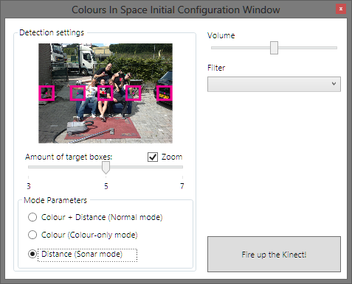

Figure 1: Configuration GUI window

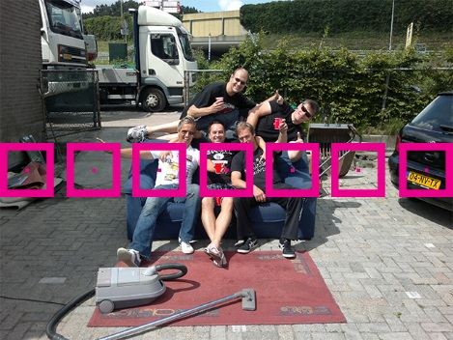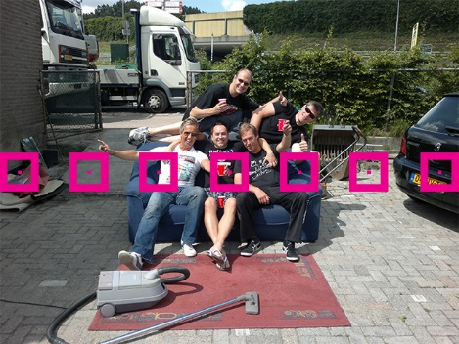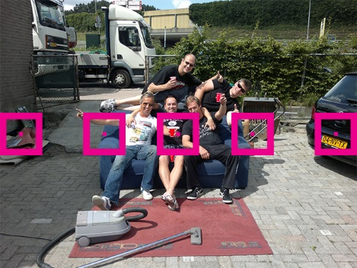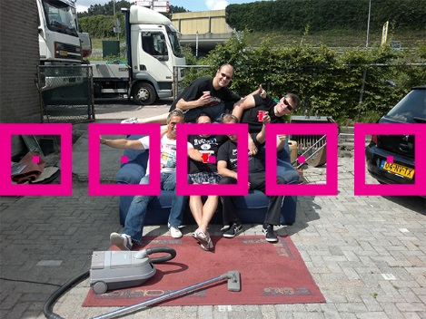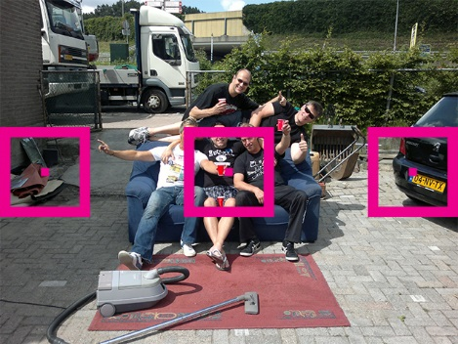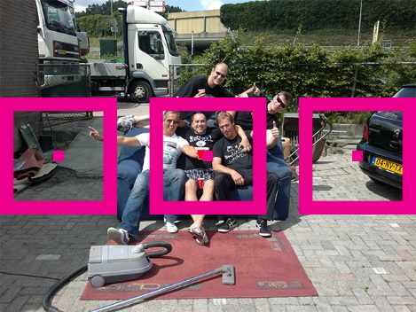

Figure 2: Illustration of the view of the sensor and the parts from which the color information is processed

List of possible voice commands

|  |  |  |
| --- | --- | --- |
| *Keyword* | *Sub-keyword* | *Command* |
| Device | Volume | Up |
| Device | Volume | Down |
| Device | Targets | Up |
| Device | Targets | Down |
| Device | Mode | Sonar |
| Device | Mode | Colour |
| Device | Mode | Mixed |
| Device | Filter | Next |

Figure 3: List of possible voice commands. "Device" is a placeholder